**Ideation Phase**

**Define the Problem Statements**

| Date | 30 August 2025 |
| --- | --- |
| Team ID | LTVIP2025TMID61036 |
| Project Name | DocSpot: Seamless Appointment Booking for Health |
| Maximum Marks | 2 Marks |

**Customer Problem Statement :**

To define the core problems patients, doctors, and clinic administrators face while managing appointments, and use those insights to guide the development of DocSpot: Seamless Appointment Booking for Health.

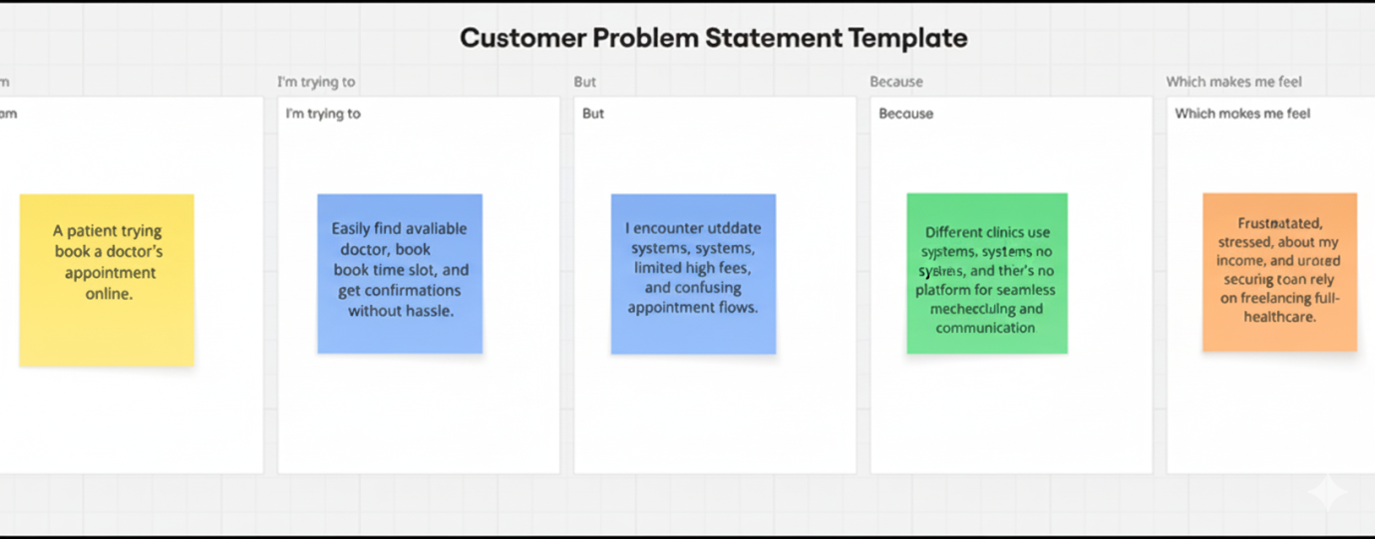

| **Problem Statement (PS)** | **I am (Customer)** | **I’m trying to** | **But** | **Because** | **Which makes me feel** |
| --- | --- | --- | --- | --- | --- |
| PS-1 | A patient. | Book an appointment with a doctor easily. | Most clinics still rely on manual booking or phone calls | There is no single seamless digital platform for real-time doctor availability. | Frustrated, anxious, and unsure if I’ll get timely care. |
| PS-2 | A doctor. | Manage my appointments efficiently. | I often face overlapping schedules or no-shows. | There is no automated system for reminders and real-time updates. | stressed and unable to optimize my consultation time. |
| PS-3 | A clinic administrator. | Streamline patient-doctor scheduling. | Manual processes take too much time and lead to errors. | Multiple staff handle calls and paper-based logs. | overwhelmed and unable to provide a smooth patient experience. |